## CHAITANYA BHARATHI INSTITUTE OF TECHNOLOGY (A)

**Gandipet , Hyderabad – 500075**



MINI PROJECT REPORT ON

**MORSE CODE GENERATOR USING LABVIEW**

submitted in partial fulfillment for the award of the degree of

BACHELOR OF ENGINEERING IN

ELECTRONICS AND COMMUNICATIONENGINEERING

SUBMITTED BY:

**V.ANURAG (160116735145)**

**K.CHANDRA SAI KIRAN (160116735147)**

**M.HIMAMSU (160116735149)**

**MD. JANI PASHA (160116735153**)

UNDER THE GUIDANCE

OF

**G.MALLIKHARJUNA RAO SIR**

Asst.Professor , ECE Dept.

Index

1. Introduction 3
2. AIM 3
3. Description of Morse Code 3
4. Front Panel Description 4
5. Block Diagram Description 4
6. Results and discussion 5
7. Conculsion 5
8. References 5
9. URL of vi files 5

# 1.Introduction

Morse code is a method of sending text messages by keying in a series of electronic pulses, usually represented as a short pulse (called a "dot") and a long pulse (a "dash"). The code was devised by Samuel F. B. Morse in the 1840s to work with his invention of the telegraph, the first invention to effectively exploit electromagnetism for long-distance communication. The early telegrapher, often one who was at a railroad station interconnected with others along miles of telegraph pole lines, would tap a key up and down to send a succession of characters that the receiving telegrapher could read from tape (later operators learned to read the transmissions simply by listening). In the original version, the key down separated by a pause (key up) from the next letter was a dot (or, as it sounded to the telegrapher, a "dit") and the key down quickly twice in succession was a dash (a "dah" or "dit-dit"). Each text character was represented by a dot, dash, or some combination.

In the late 1800s, as new keying technology became prevalent, a somewhat different representation of dots and dashes was used for certain letters in what became known as the International Morse Code or Continental Code. American Morse code, however, continued to be used in the U.S. into the 1960s.

There are various stories concerning how the Morse code was originally developed. According to one account, Samuel Morse went to a printer's shop and counted the amount of printer type the printer had for each letter of the alphabet. He then interpreted these counts as approximations of the relative frequency of each letter in typical English text. He organized the Morse code so that the shortest symbols were associated with the most frequent characters.

2. AIM

To simulate a Morse code generator using Lab VIEW

# 3. Description of Morse Code

Morse code is usually transmitted by on-off keying of an information carrying medium such as electric current, radio waves, visible light or sound waves. The current or wave is present during time period of the dot or dash and absent during the time between dots and dashes.

Morse code can be memorized, and Morse code signaling in a form perceptible to the human senses, such as sound waves or visible light, can be directly interpreted by persons trained in the skill. Because many non-English natural languages use other than the 26 Roman letters, Morse alphabets have been developed for those languages.

International Morse code is composed of five elements:

1. short mark, dot or "dit" (-): "dot duration" is one time unit long
2. longer mark, dash or "dah" (.): three time units long
3. inter-element gap between the dots and dashes within a character: one dot duration or one unit long
4. short gap (between letters): three time units long
5. medium gap (between words): seven time units long

# 4.Front Panel

1. Right Click on the block diagram to create a String Control
2. The following is the Front panel

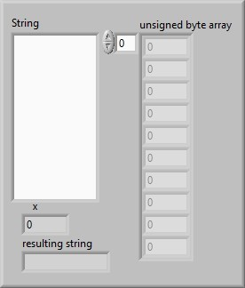

Fig 1: front panel

# 5. Block Diagram

1. Right click on the block diagram to add for loop, array size, String to byte array converter.
2. The string is converted into a byte array and then to characters using Type Casting.
3. Then using Sting Case Select the Characters are converted to DIT DOT String.
4. Using Steps 1 to 3 this string is again converted to Characters.
5. These Characters (- , .) are converted to delays to play wave form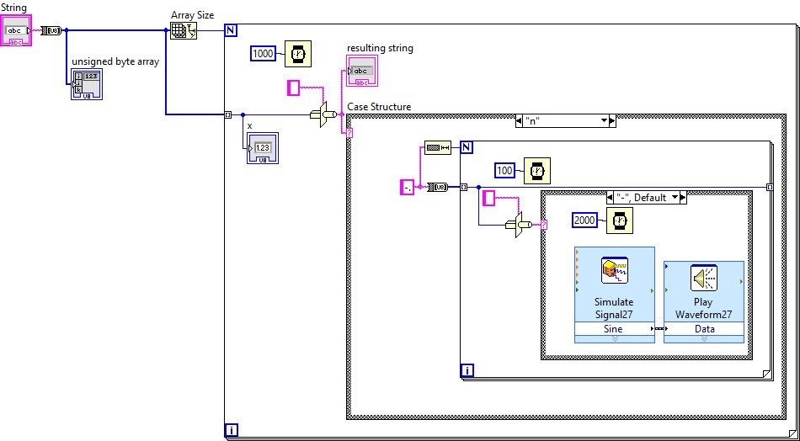.

Fig 2: Block Diagram

# 6. Results and Discussion

* Input Data 1 : this is our mini project
* Output Data 1: - .... .. ... .. ... --- ..- .-. -- .. -. .. .--. .-. --- .--- . -.-. –
* Input Data 2: this is a Morse code generator
* Output Data 2: - .... .. ... .. ... .- -- --- .-. ... . -.-. --- -.. . --. . -. . .-. . - .-.

DOT (.) (Short Pulse) DIT(-) (Long Pulse)

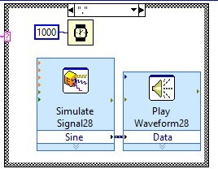 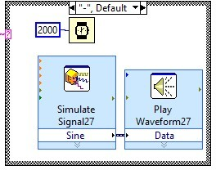

Fig 3: short pulse Fig 4 : long pulse

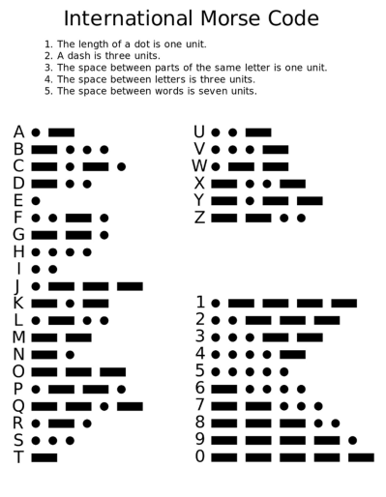

Fig 5:lookup table

# 7. Conclusion

A Morse Code Generator has been simulated using LabVIEW software with the input as a string and Audio output.

8. References

[1] International Telecommunication Union. October 2009. [Archived](https://web.archive.org/web/20121106142719/http:/www.itu.int/rec/R-REC-M.1677-1-200910-I/) from the original on 6 November 2012. Retrieved 23 December 2011.

[2] F. S. Beechey, Electro-Telegraphy, London: E. & F. N. Spon, 1876, p. 71

[3] F. J. Camm, *Radio Engineer's Pocket Book*, 2nd ed., 1941, p. 72

[4] U.S. Army, FM 24-5, Signal Communication, 1939, pp. 83, 101-108, 227

9. URL to vi files : https://tinyurl.com/LabVIEWminiproject